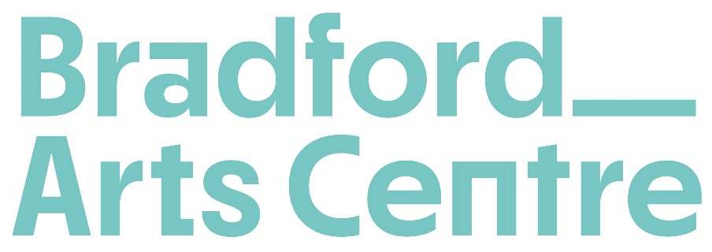

**Equal Opportunities Monitoring Form**

Bradford Arts Centre operates a policy of equal opportunities and wishes to ensure that all applicants are considered solely on their merits. This form is designed to ensure that the Equal Opportunities Policy is effectively implemented and enable us to check that all decisions are not influenced by unfair or unlawful discrimination. To help us to do this, we ask that all applicants for employment complete this form. The information is strictly confidential and will be used for monitoring the Policy only. It will not be available to anyone involved in considering an application.

**What is your ethnic group?**

ARAB  Arab

ASIAN / ASIAN BRITISH  Bangladeshi

Chinese

Indian

Pakistani

Prefer to self describe:

BLACK  Black African

Black Caribbean

Prefer to self describe:

LATIN AMERICAN  Latin American

MIXED BACKGROUND  Asian and White

Black African and White

Black Caribbean and White

Prefer to self describe:

WHITE  Gypsy, Roma or Irish Traveller

White British

White Irish

Prefer to self describe:

Prefer to self describe:

**How would you describe your gender identity?**

Man  Non-Binary  Woman

Prefer not to say  Prefer to self describe:

**Is your gender identity the same as the sex you were assigned at birth?**

Yes  No  Prefer not to say

**Do you identify as a D/deaf or disabled person, or have a long term health condition?**

Yes  No  Prefer not to say

**Do you identify as neurodivergent?**

Yes  No  Prefer not to say

**How would you describe your sexual orientation?**

Bisexual  Heterosexual/Straight  Not known

Gay Man  Queer  Prefer not to say

Gay Woman/Lesbian  Prefer to self describe:

**What is your religion or belief system?**

Buddhist  Christian  Hindu

Jewish  Muslim  Sikh

No religion or belief  Prefer to self describe

**Are you related to, or have a relationship which would present a conflict of interest with, any Member of the Board or Staff of Bradford Arts Centre?**

YES  NO

If yes, please give the name(s) and state the nature of the relationship.

**Name:**  **Relationship:**

**HOW DID YOU FIND OUT ABOUT THIS POST?**