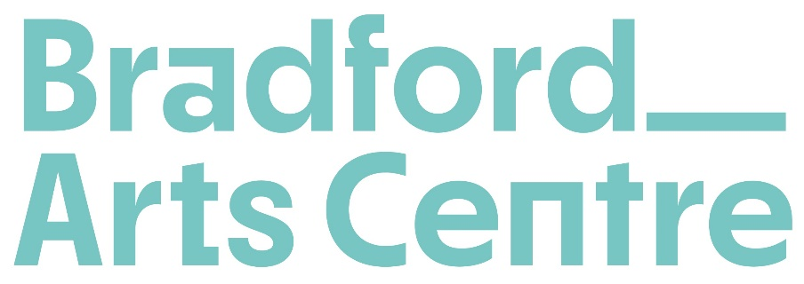

Job Description: Marketing Manager
Salary: | £30,000 gross pa
Term: | Full-time, permanent
Reports to: | Head of Operations
Management Responsibility: | Marketing Officer  Freelance PR Consultants  Freelance designers  Volunteers (performance evenings)
Holiday entitlement: | 28 days including statutory and bank holidays, increasing by 1 day per year per full year of employment to a maximum of 33 days. Plus an additional discretionary allocation to cover mandatory closure over Christmas and New Year.
Period of notice: | Three months, on completion of a successful three-month probationary period.
Location: | principally Bradford Arts Centre, 1 Forster Square, Bradford, BD1 4TY

About Bradford Arts Centre

Formerly known as Kala Sangam, Bradford Arts Centre is a performance space, meeting place and creative home that spotlights the city’s brilliant culture, set in the historic heart of Bradford city centre. We want everyone to feel at home. It’s free to come in, and most of our performances are ‘Give What You Decide’. We offer high-quality meeting room hire in a stimulating building and are proud to be the only centre in the North of England offering free performance studio space and tailored support for artists.

The Role:

The Marketing Manager is responsible for devising and delivering effective marketing campaigns that will grow our audiences, raise the organisation’s profile regionally and nationally, and increase commercial usage of our spaces. The postholder will manage the company’s Box Office system (Ticket Solve) and line manage the Marketing Officer.

This post will involve some evening and weekend working, and may also require infrequent local, regional and national travel.

Key Responsibilities:

Marketing

- Develop and deliver an effective Marketing Strategy, aligned with the company’s Business Plan, that will see growth across all strands of Bradford Arts Centre’s business.
- Develop and deliver effective marketing campaigns that result in increased attendance at Bradford Arts Centre’s performances. Bradford Arts Centre’s aim is that these audiences will reflect the rich diversity of the district.
- Support the Head of Operations and Business Development Manager by developing effective marketing campaigns to increase commercial usage of the building.
- Manage Bradford Arts Centre’s brand and identity, ensuring that our new brand is used correctly across all platforms by staff and external stakeholders.
- Working with the Marketing Officer, maintain and grow our e-mailing list and social media channels.
- Manage Bradford Arts Centre’s website, working with the Marketing Officer to create content and ensure information uploaded is accurate and best practice.
- Manage the company’s Box Office system (Ticket Solve), working with the Marketing Officer to ensure performances are uploaded, audience data is collected (and reported as required), data sharing agreements are in place and GDPR legislation is followed.
- Plan, write and oversee the design of strategic public facing documents – including the company’s Annual Review.
- Oversee the creation of all printed and digital materials, liaising with designers and authoring appropriate, accurate copy.
- Ensure regular evaluation of all marketing and audience development activity is carried out and maintain rigorous record keeping systems for monitoring purposes and to inform reporting to stakeholders and our Board of Trustees.
- Maintain and develop positive relationships with a range of stakeholders including local, regional and national press.

Management

- Line Manage the Marketing Officer, ensuring they are supported to deliver their roles and responsibilities effectively.
- Manage relationships with external freelancers including photographers and our current Freelance PR support (The Space In Between) and designers (Out of Place).
- Effectively manage the company’s Marketing budget, ensuring marketing activity is delivered on time and to budget.
- Manage the staffing of the Ticket desk/Reception on performance evenings and coordinate the distribution and collection of audience surveys.

General Duties of all Staff

- At all times act as an ambassador for the company.
- Help maintain a positive work environment, working collaboratively with other staff and contributing to fortnightly all-staff meetings.
- Assist at Bradford Arts Centre performances, corporate events, education and outreach delivery and other activities as required.
- Work in accordance with Health and Safety, Safeguarding and all appropriate legislation, in line with company policies and procedures.
- Support Bradford Arts Centre to be a safe place to work and develop; freely and promptly raising any issues or concerns to either the Chief Executive Officer or Chair of the Board of Trustees in line with the company’s complaints/grievance procedures.
- Carry out all duties with an understanding and commitment to equal opportunities and ensure that this understanding and commitment is implemented across the company.
- Undertake any other duty or responsibility which may reasonably be requested.

Person Specification

Essential Skills and Experience

- Proven experience designing and delivering effective marketing campaigns and strategy for cultural events and activity.
- Proven experience managing budgets – particularly using smaller budgets to generate a large impact.
- Knowledge, and preferably experience of, using marketing to effectively engage diverse communities.
- Experience of using a range of marketing techniques (including online / social media) to engage audiences.
- Good attention to detail, strong proof-reading skills, and effective management processes.
- A team player with the ability to self-motivate and motivate others.

Desirable Skills and Experience

- Prior experience working for a cultural venue and/or NPO.
- Experience of managing a Box Offices system – particularly for a venue and over a number of events.
- Previous experience acting as a Line Manager.
- Understanding of the communities and specific challenges and opportunities facing Bradford.

Bradford Arts Centre is committed to safeguarding and promoting the welfare of children, young people and vulnerable adults and expects all staff to share this commitment. Employment in this post will be subject to a successful Basic Disclosure and Barring Service (DBS) application.

Bradford Arts Centre Organigram

